Practice Exercise

This document provides a list of exercises to be practiced by learners. Please raise a feedback in Talent Next, should you have any queries.

|  |  |
| --- | --- |
| Skill | JavaScript |
| Document Type | Lab Practice Exercises |
| Author | L & D |
| Current Version | 1.0 |
| Current Version Date | 16-Jun-2021 |
| Status | Active |

Document Control

|  |  |  |  |
| --- | --- | --- | --- |
| Version | Change Date | Change Description | Changed By |
| 1.0 | 16-Jun-2021 | Added problem statements on Defining class and creating custom objects, working with pre-defined classes and DOM manipulations | Pradeep Chinchole |

Contents

Practice Exercise 1

Document Control 2

Problem Statement 1: Setting up JS Environment & Test JS 4

Problem Statement 2: Create Object using Object Constructor. 5

Problem Statement 3: Create Object using Object Prototype. 6

Problem Statement 4: Create Object using JSON. 7

Problem Statement 5: Defining Class in JS. 8

Problem Statement 6: Performing String Operations. 9

Problem Statement 7: Performing Date Operations. 10

Problem Statement 8: Performing Array Operations. 11

Problem Statement 9: Getting the values from Form using JS DOM. 12

Problem Statement 10: Performing Math Operations 13

Note: Every Problem Statement start in a new page

Problem Statement 1: Setting up JS Environment & Test JS

**Important Instructions:**

* Refer the **Lab Access Guide - PEP Up** document for accessing the JavaScript live online playground.
* Refer <https://playcode.io/new/> link to access online playground.
* By default, the schema used is **My Schema.**

Introduction

1. Create a folder in which to work.
2. Create a new HTML file in a text editor. Call it index.html.
3. Create a JavaScript file in a text editor. Call it script.js.
4. Put an alert in the script file, like this: alert('Hello world').
5. Use a script tag to link the JavaScript file into the HTML file.
6. Open the HTML file in a browser Google Chrome/Edge. See the alert?

**Sample output:**

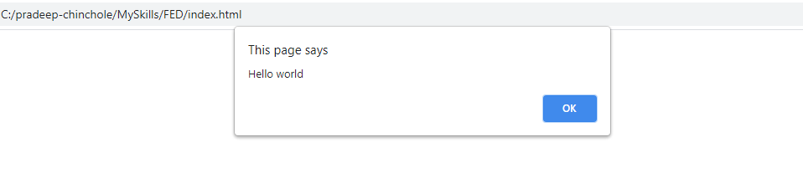

Problem Statement 2: Create Object using Object Constructor.

1. Create the Customer object using the object constructor.
2. Add below properties to the new customer Object.
   * id
   * firstName
   * lastName
   * email
   * mobile
   * gender
   * address
   * dateOfBirth
   * city
   * state
   * country
3. Add a method showDetails() method to the Customer object to show Customer Details on the browser as well as browser console.
4. Instantiate the Customer object.
5. Display Customer Details by calling showDetails() method of Customer Object.

**Sample output:**

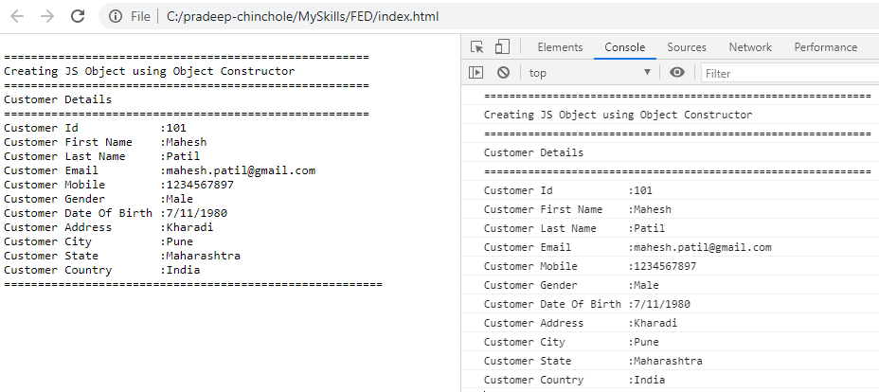

Problem Statement 3: Create Object using Object Prototype.

1. Create Product object using the Object Prototype.
2. Add below properties to the Product Object.
   * productId
   * productName
   * productPrice
3. Add a method showDetails() to the Product object and write the code to render Product details.
4. Instantiate the Product object.
5. Display Product Details by calling showDetails() method of Product Object.

**Sample Output:**

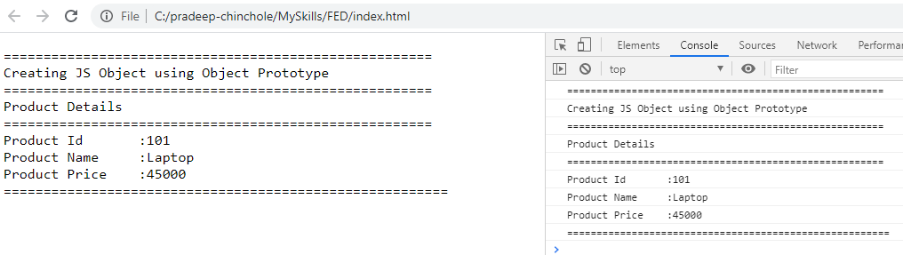

Problem Statement 4: Create Object using JSON.

1. Create Account object using JSON.
2. Add below properties to the Account Object.
   * accountNumber
   * name
   * balance
   * mobile
   * pan
3. Add a method showDetails() to the Account object and write the code to render Account details.
4. Instantiate the Account object.
5. Display Account Details by calling showDetails() method of Account Object.

**Sample Output:**

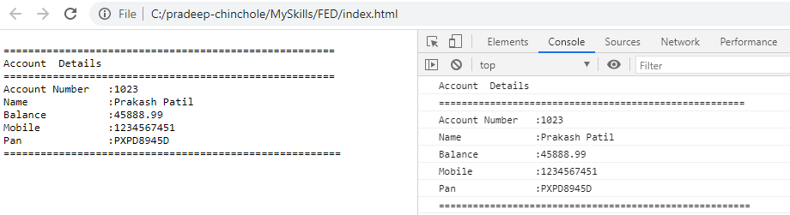

Problem Statement 5: Defining Class in JS.

1. Create class Book.
2. Add constructor with below properties in Book class.

* id
* name
* author
* price

1. Add a method showDetails() to the Book object and write the code to render Book details.
2. Instantiate the Book object.
3. Display Book Details by calling showDetails() method of Book Object.

**Sample Output:**

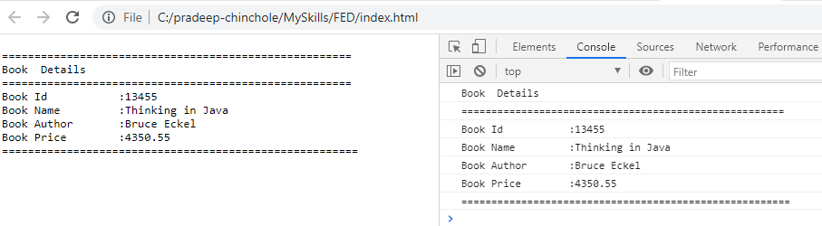

Problem Statement 6: Performing String Operations.

Write a JavaScript Program to perform below operations on array products.

1. Display the String.
2. Calculate the length of String.
3. Convert String into lowercase & uppercase.
4. Concatenate the Strings using concat() function & + operator.
5. Display character at specific position.
6. Display indexOf & lastIndexOf character in a String.
7. Finding the specific portion of string using substr() and substring() function
8. Compare the strings using == operator & localeCompare() function
9. Cutting the spaces before and after string

**Consider below 4 input strings:**

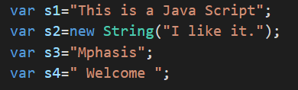

**Sample Output:**

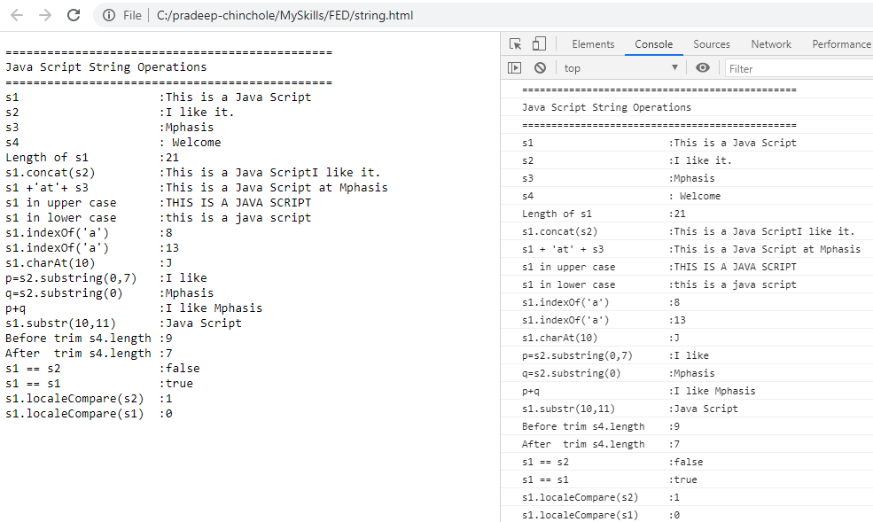

Problem Statement 7: Performing Date Operations.

Write a JavaScript Program to perform below operations on Date object.

1. Create a Date Object.
2. Display date in different format.
3. Use different methods of Date object.
4. Compare Two Date objects.

**Consider below Date objects:**

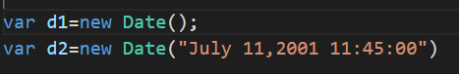

**Sample Output:**

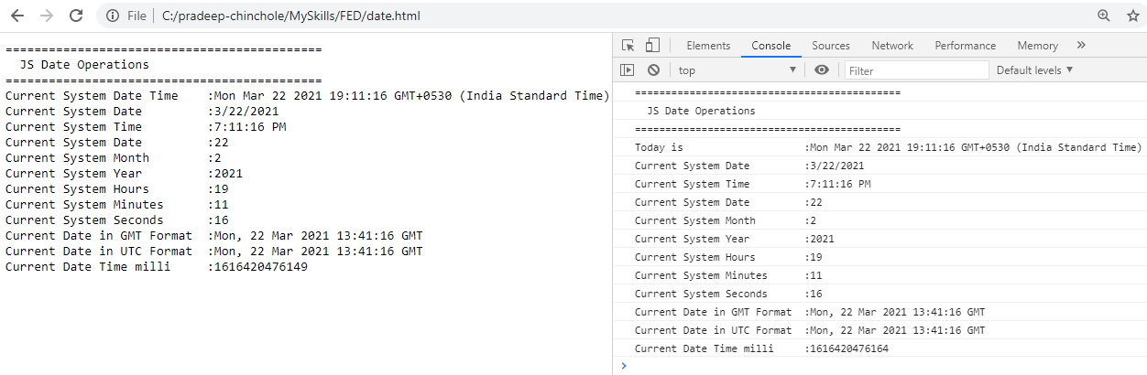

Problem Statement 8: Performing Array Operations.

Write a JavaScript Program to perform below operations on array products.

* 1. Add Product
  2. Print the number of products in the array.
  3. Show Product with id 110.
  4. Update the price of product with id 110 to 15000.87.
  5. Delete the product with id 104.
  6. Show the product details which belongs to Electronics category.
  7. Show the product details whose price is between 3000 & 30000.

**Sample Array of products:**

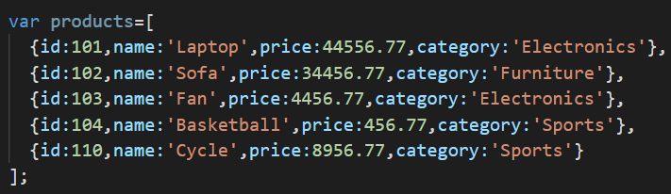

**Sample Output:**

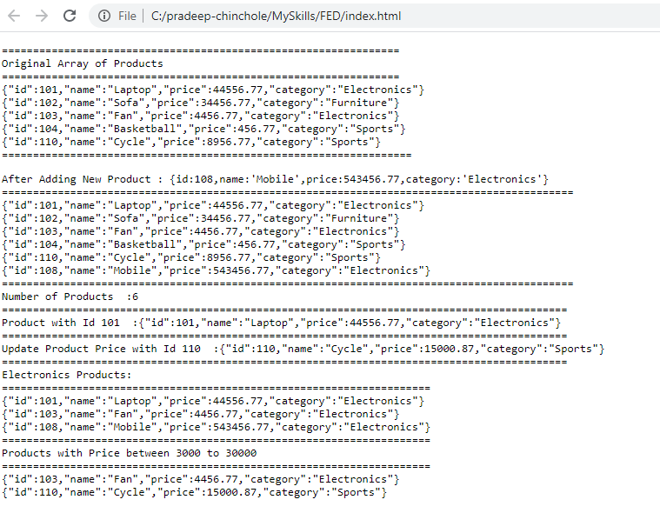

Problem Statement 9: Getting the values from Form using JS DOM.

Write a JavaScript function **showDetails()** to greet the user by showing First Name & Last Name in alert box whenever **Greet** button is submitted.

Refer the html page available in **\Code Snippet\Problem Statement 9\welcome.html**

**Sample output:**

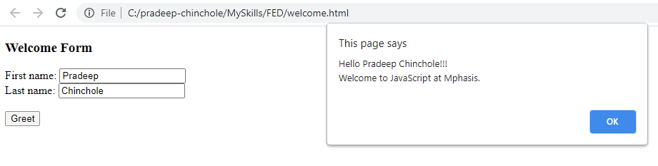

Problem Statement 10: Performing Math Operations

Write a JS functions to **display addition, subtraction, division, multiplication** of numbers entered in the text field inside the text area whenever specific operation button is clicked.

Refer the html page available in **\Code Snippet\Problem Statement 10\calculator.html**

**Sample output:**

